**Lab Activity:** Creating and Monitoring an Alarm for an EC2 Instance.

**Objective:** This lab will guide you through the process of creating an Amazon EC2 instance, setting up a CloudWatch alarm for CPU Utilization, and simulating high CPU utilization to trigger the alarm.

**Step 1:** Launch an EC2 Instance

1. Sign into the AWS management console and open the Amazon EC2 console.
2. Create an instance as our previous lessons. Use the Amazon Linux 2 AMI and a t2.micro instance type.

**Step 2:** Create a CloudWatch Alarm

1. Search for CloudWatch and access CloudWatch

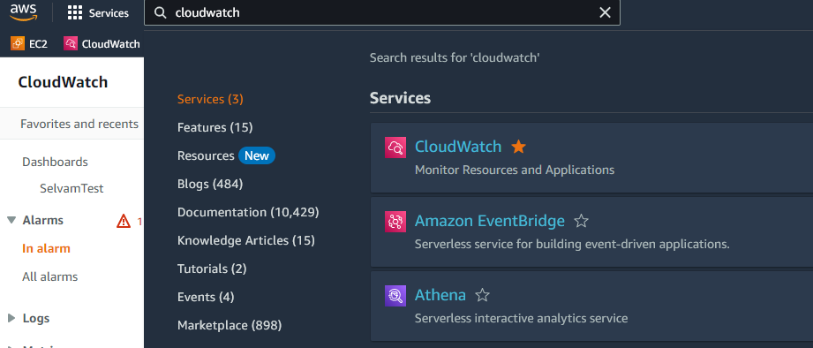

1. In the navigation pane, choose **Alarms** > **Create Alarms**

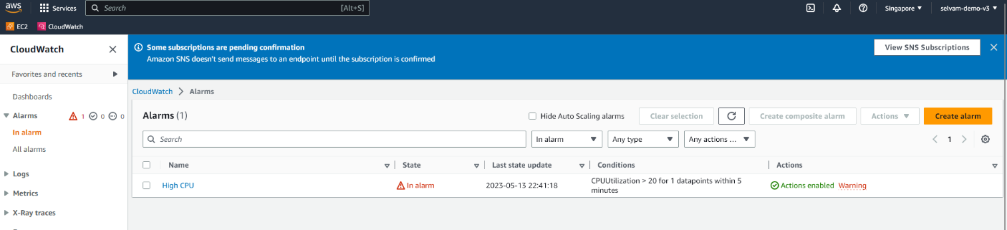

1. In “Select metric”, choose “EC2 Per-Instance Metrics”.

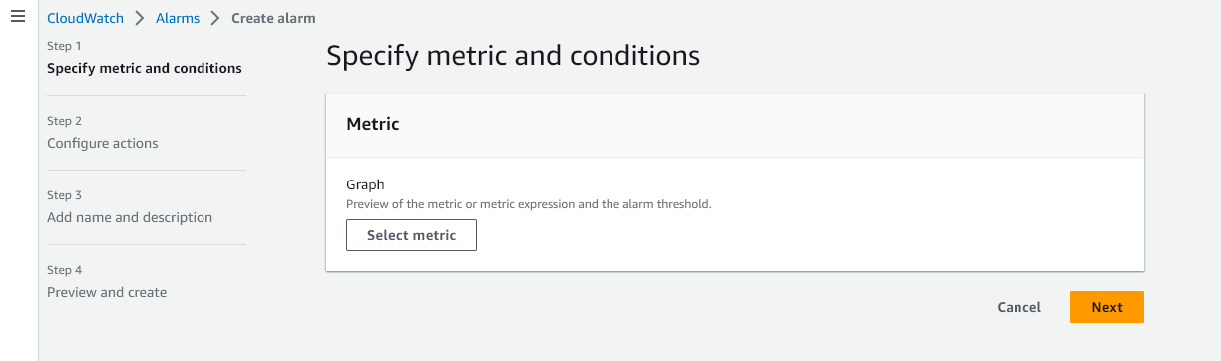

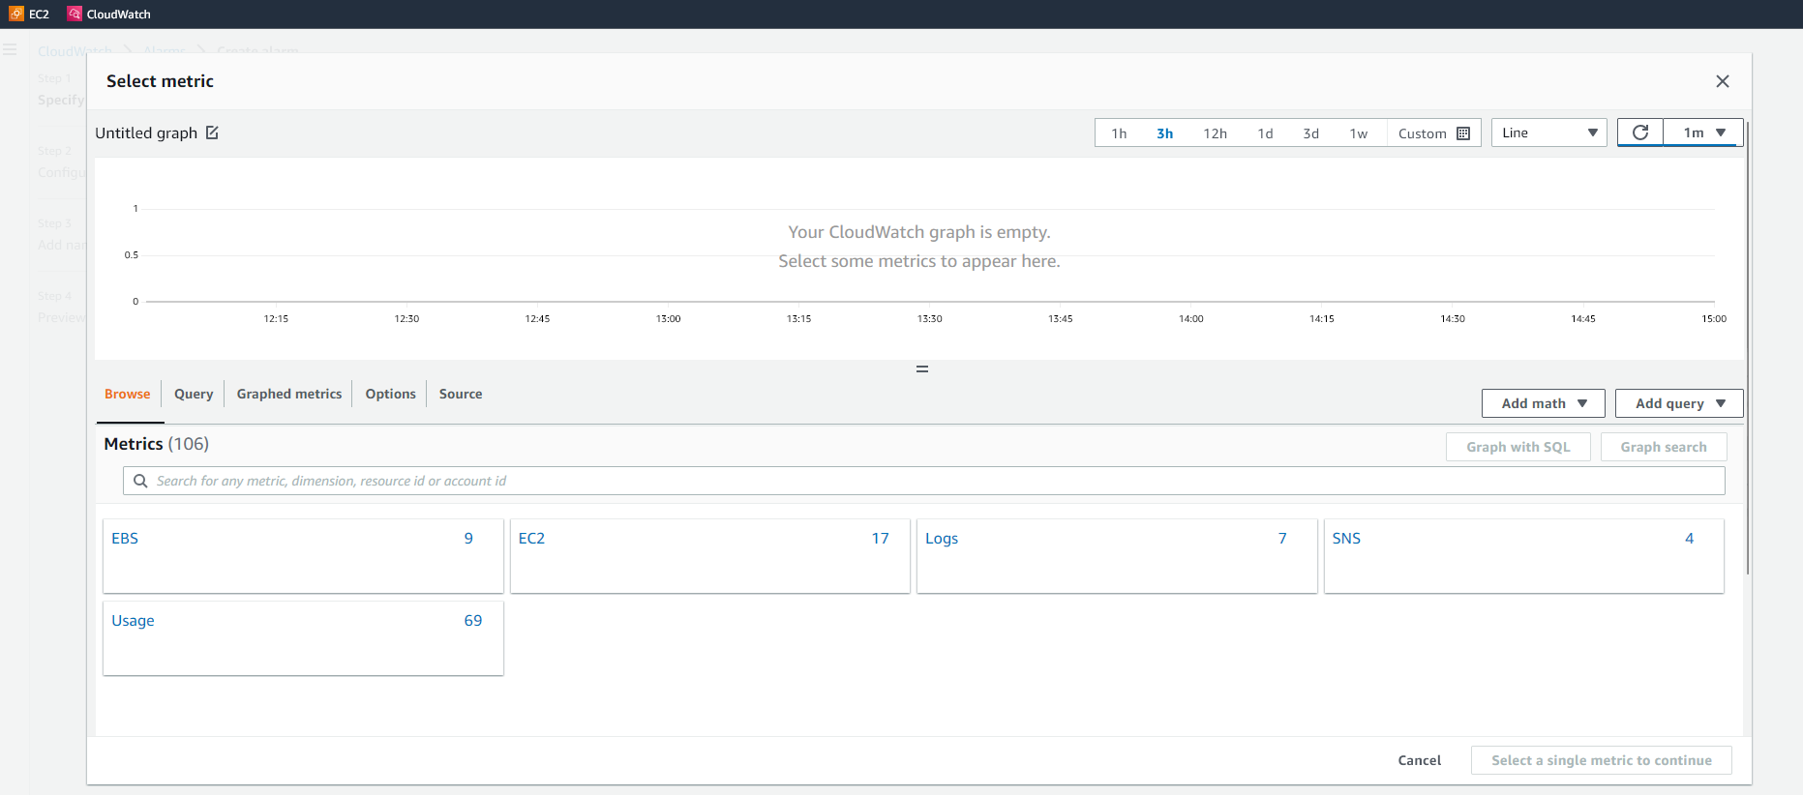

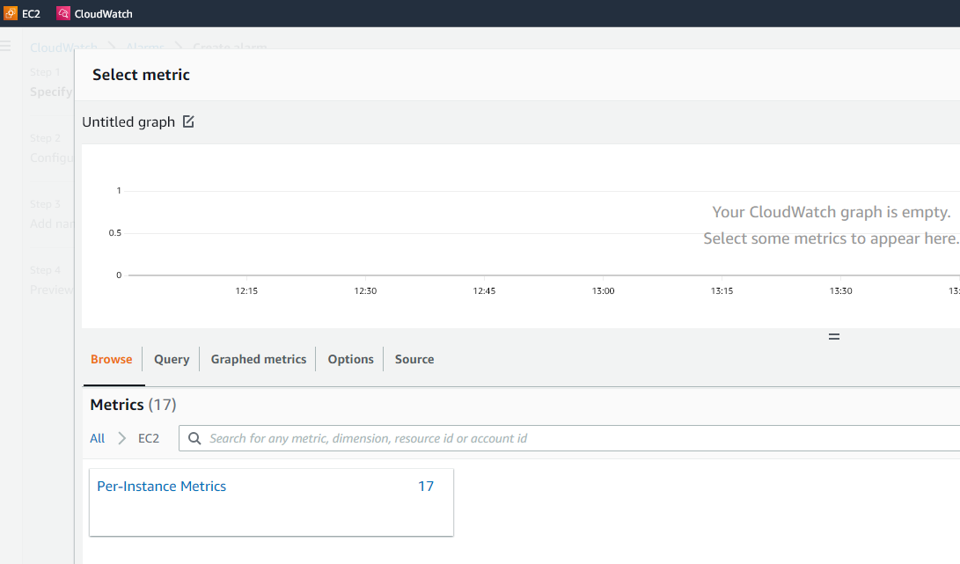

1. Select the checkbox next to the instance you just created and choose the “CPUUtilization” metric.

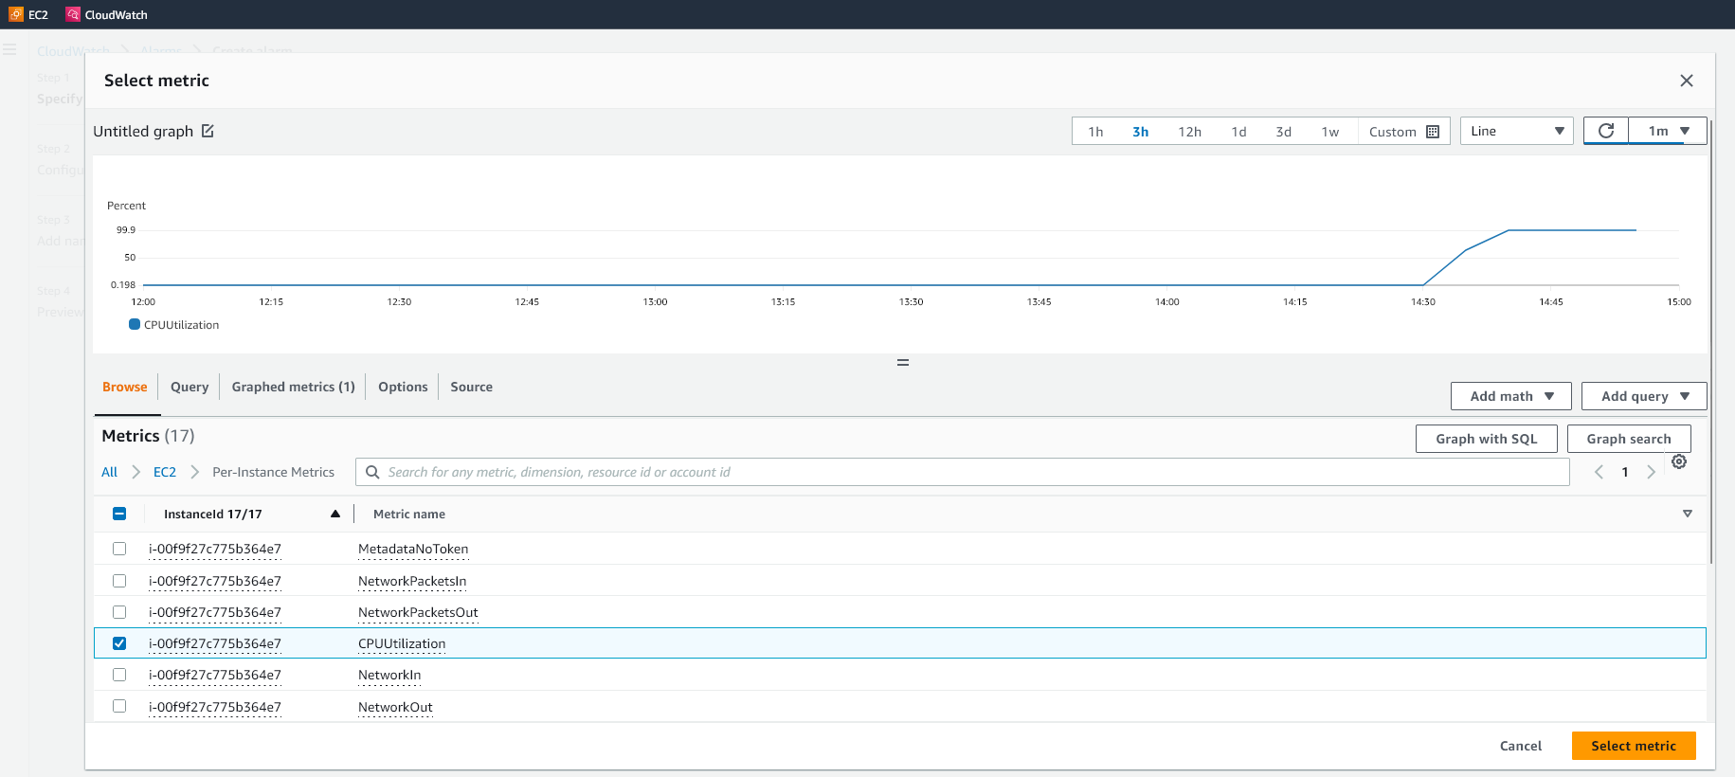

1. Define the alarm settings: set the threshold to be greater than 20% for 1 consecutive period. (We are setting to 20% just for this lab activity. In real life, it really depends and usually it is set to greater than 60-70%)

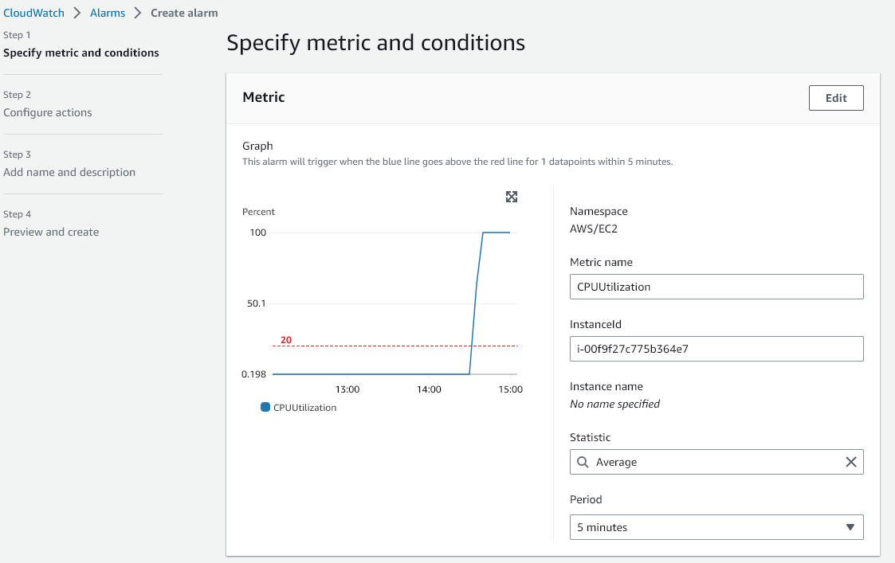

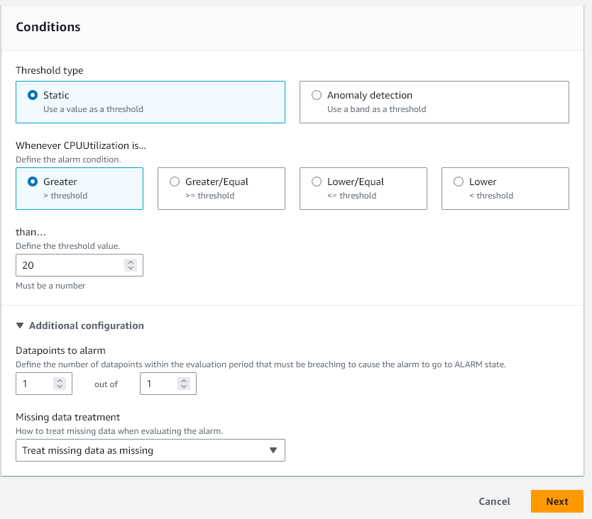

1. In actions, choose to send a notification to an existing SNS topic or create a new one. Then choose “Create Alarm”

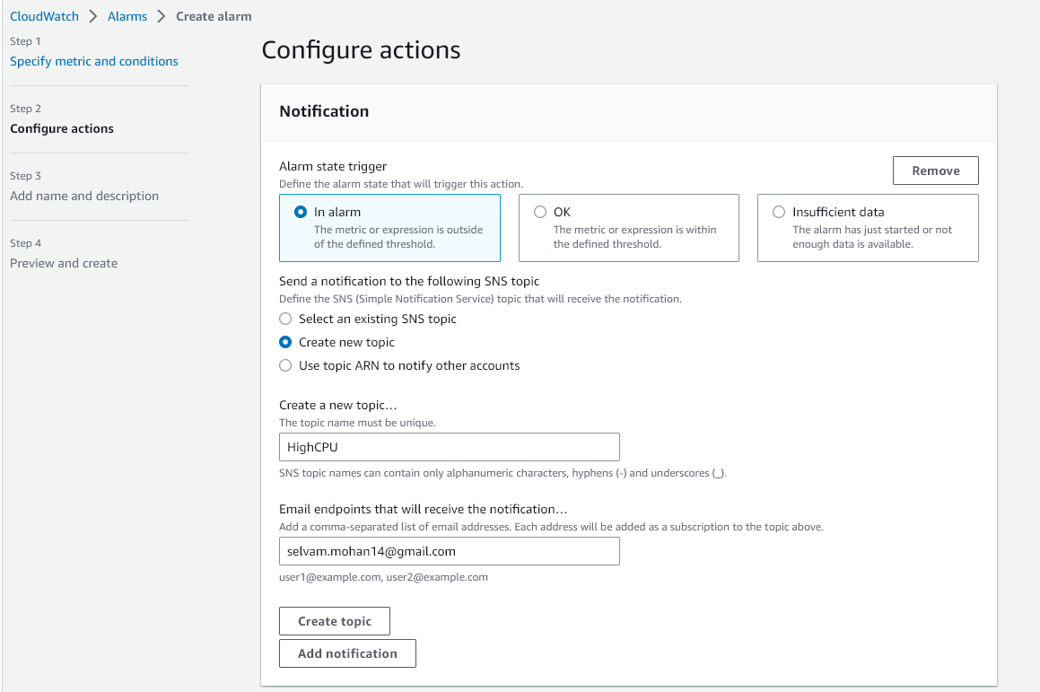

**\*SNS subscription needed. Proceed without SNS**

**Step 3:** Simulate High CPU Utilization

1. Connect to your EC2 instance using EC2 Instance Connect

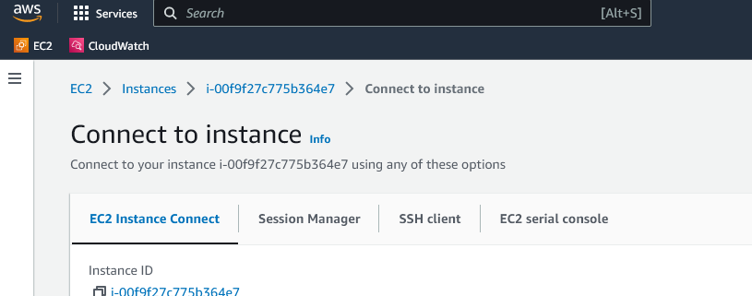

1. Install stress

*[EC2-user ~]$ sudo yum install stress*

1. Once installation completes, run the following to generate CPU load to trigger the alarm.

[EC2-user ~]$ stress - -cpu 5

(Another way is to type this “yes > /dev/null &” to load the CPU process.)

**Step 4:** Monitor the Alarm

1. Go back to the CloudWatch console and navigate to “Alarms”
2. You should see the alarm change its state from “OK” to “Alarm” once the CPU Utilization goes beyond the defined threshold.

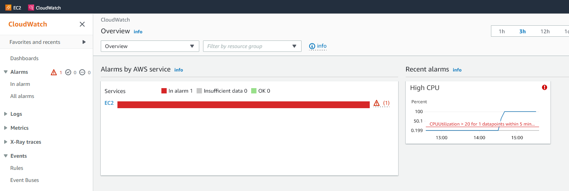

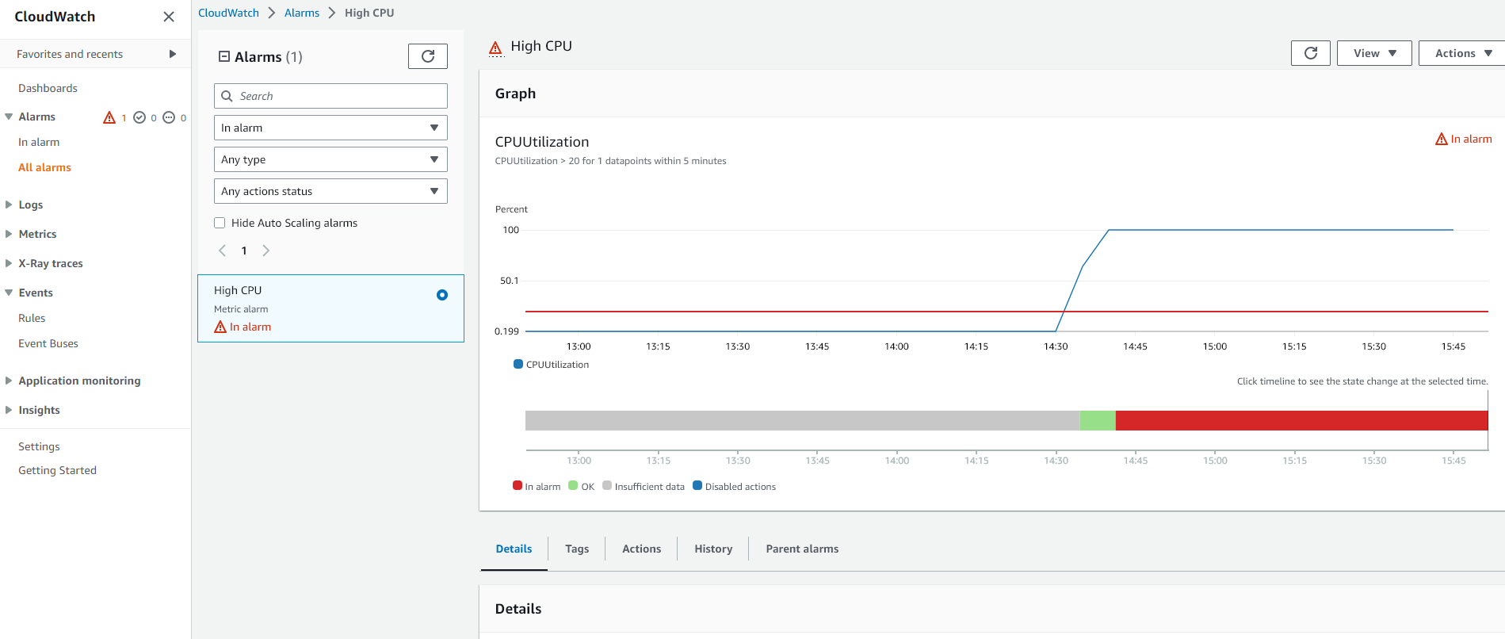

1. After stopping stress, you can see that the CPU Utilization will start to drop. Alarm will be in OK status

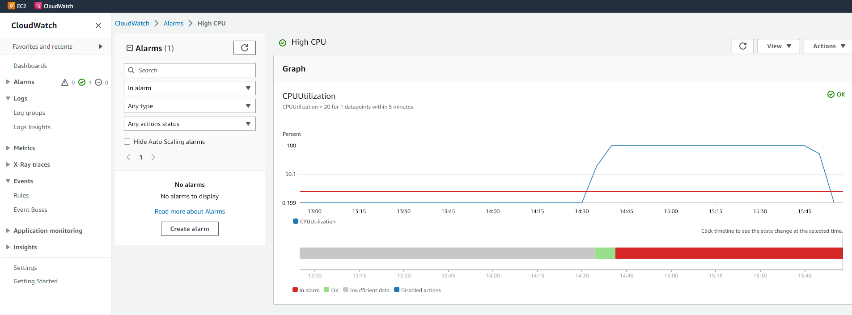

**Step 4:** Clean Up

1. Don’t forget to terminate your EC2 instance and delete CloudWatch alarm to avoid any unnecessary charges.

**Thank you for completing the lab. By now, you should have hands-on experience with creating and monitoring CloudWatch alarms for EC2 instances. 😊**